Que-3: Create table given below: Employee and Incentive.

CREATE TABLE Employee(

Employee_id int PRIMARY KEY AUTO_INCREMENT NOT NULL,

First_name varchar(50),

Last_name varchar(50),

Salary bigint(50),

Joining_date varchar(50),

Department varchar(50)

);

INSERT INTO employee(First_name,Last_name,Salary,Joining_date,Department) VALUES("John","Abraham",1000000,"01-JAN-13 12.00.00 AM","Banking"),("Michael","Clarke",800000,"01-JAN-13 12.00.00 AM","Insurance"),("Roy","Thomas",700000,"01-FEB-13 12.00.00 AM","Banking"),("Tom","Jose",600000,"01-FEB-13 12.00.00 AM","Insurance"),("Jerry","Pinto",650000,"01-FEB-13 12.00.00 AM","Insurance"),("Philip","Mathew",750000,"01-JAN-13 12.00.00 AM","Services"),("TestName1","123",650000,"01-JAN-13 12.00.00 AM","Services"),("TestName2","Lname%",600000,"01-FEB-13 12.00.00 AM","Insurance");

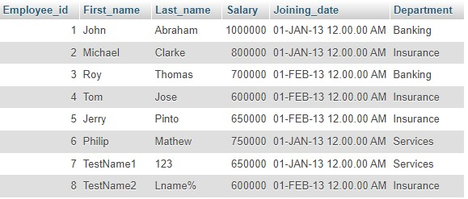

CREATE TABLE Incentive(

Employee_ref_id int(10) NOT NULL,

Incentive_date varchar(50),

Incentive_amount int(50)

);

INSERT INTO incentive(Employee_ref_id,Incentive_date,Incentive_amount) VALUES(1,"01-FEB-13",5000),(2,"01-FEB-13",3000),(3,"01-FEB-13",4000),(1,"01-JAN-13",4500),(2,"01-JAN-13",3500);

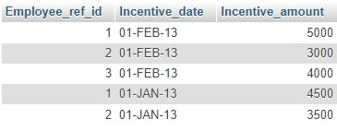

1. Get First_Name from employee table using Tom name “Employee Name”.

* SELECT * FROM employee WHERE First_name="Tom";



1. Get FIRST_NAME, Joining Date, and Salary from employee table.

* SELECT First_name,Joining_date,Salary FROM employee;

1. Get all employee details from the employee table order by First_Name Ascending and Salary descending?

* SELECT * FROM employee ORDER BY First_name ASC;

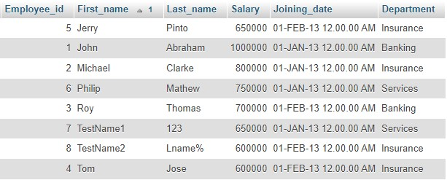

* SELECT * FROM employee ORDER BY Salary DESC;

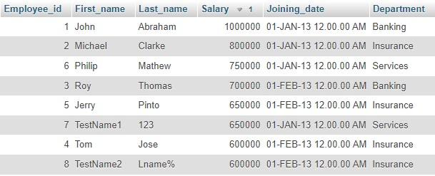

1. Get employee details from employee table whose first name contains ‘J’.

* SELECT * FROM employee WHERE First_name LIKE '%j%';

1. Get department wise maximum salary from employee table order by salary ascending?

* SELECT Department, MAX(Salary) FROM employee GROUP BY Department;

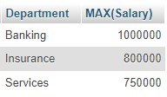

1. Select first_name, incentive amount from employee and incentives table for those employees who have incentives and incentive amount greater than 3000?

* SELECT employee.First_name,incentive.Incentive_amount FROM employee INNER JOIN incentive ON employee.Employee_id=incentive.Employee_ref_id and Incentive_amount > 3000

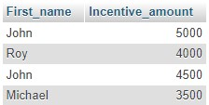

1. Create After Insert trigger on Employee table which insert records in view table

* CREATE TABLE employee_detail(

Employee_id int PRIMARY KEY AUTO_INCREMENT NOT NULL,

First_name varchar(50),

Last_name varchar(50),

Salary bigint(50),

Joining_date varchar(50),

Department varchar(50)

);

CREATE TRIGGER T1

AFTER INSERT ON employee

FOR EACH ROW

INSERT INTO employee_detail

SET action = 'INSERT' ,

Employee_id=new.Employee_id,

First_name=new.First_name,

Last_name=new.Last_name,

Salary=new.Salary,

Joining_date=new.Joining_date,

Department=new.Department,

changedat = NOW();

